Title of the work in English

*DO NOT MENTION THE NAME OF THE AUTHORS NEITHER THE INSTITUTION TO WHICH THEY BELONG*

Abstract:
Abstract of the paper in English no more than 300 words. Abstract of the paper in English no more than 300 words. Abstract of the paper in English no more than 300 words. Abstract of the paper in English no more than 300 words. Abstract of the paper in English no more than 300 words. Abstract of the paper in English no more than 300 words. Abstract of the paper in English no more than 300 words. Abstract of the paper in English no more than 300 words. Abstract of the paper in English no more than 300 words. Abstract of the paper in English no more than 300 words. Abstract of the paper in English no more than 300 words. Abstract of the paper in English no more than 300 words.

Keywords: between 3 and 5 keywords.

Introduction

Content of the introduction. Content of the introduction. Content of the introduction. Content of the introduction. Content of the introduction. Content of the introduction. Content of the introduction. Content of the introduction. Content of the introduction. Content of the introduction. Content of the introduction.

- Section 1

Content of the section 1. Content of the section 1. Content of the section 1. Content of the section 1. Content of the section 1. Content of the section 1. Content of the section 1. Content of the section 1. Content of the section 1. Content of the section 1. Content of the section 1. Content of the section 1. Content of the section 1. Content of the section 1. Content of the section 1. Content of the section 1. Content of the section 1. Content of the section 1. Content of the section 1.

- Sub section 1.1

Content of the sub section 1.1. Content of the sub section 1.1. Content of the sub section 1.1. Content of the sub section 1.1. Content of the sub section 1.1. Content of the sub section 1.1. Content of the sub section 1.1. Content of the sub section 1.1.

Table 1. Title of the table 1
Table content | Table content | Table content
Source: UNDP (1990).

Content of the sub section 1.1. Content of the sub section 1.1. Content of the sub section 1.1. Content of the sub section 1.1. Content of the sub section 1.1. Content of the sub section 1.1. Content of the sub section 1.1. Content of the sub section 1.1. Content of the sub section 1.1. Content of the sub section 1.1. Content of the sub section 1.1. Content of the sub section 1.1. Content of the sub section 1.1. Content of the sub section 1.1. Content of the sub section 1.1. Content of the sub section 1.1. Content of the sub section 1.1. Content of the sub section 1.1. Content of the sub section 1.1. Content of the sub section 1.1. Content of the sub section 1.1. Content of the sub section 1.1. Content of the sub section 1.1. Content of the sub section 1.1. Content of the sub section 1.1. Content of the sub section 1.1. Content of the sub section 1.1. Content of the sub section 1.1. Content of the sub section 1.1. Content of the sub section 1.1. Content of the sub section 1.1. Content of the sub section 1.1. Content of the sub section 1.1. Content of the sub section 1.1. Content of the sub section 1.1. Content of the sub section 1.1. Content of the sub section 1.1 (Jolly, 2010).

Figure 1. Title of the figure 1
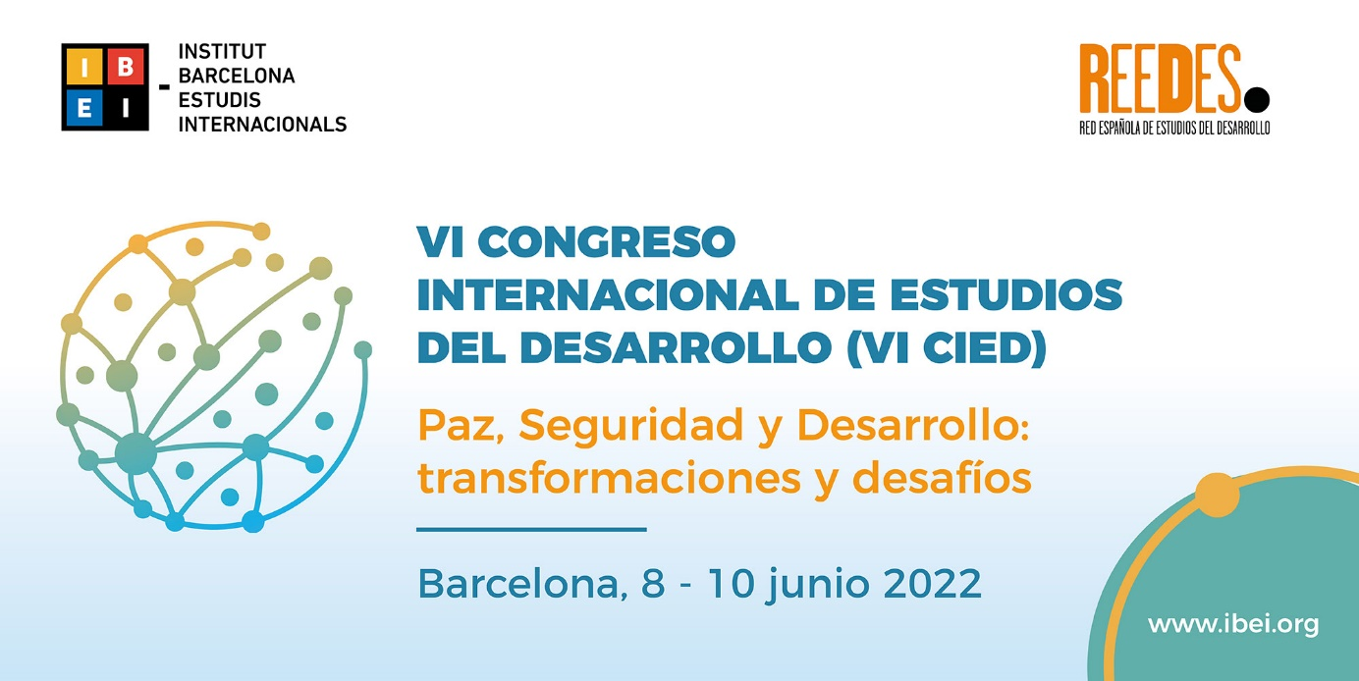
Source: own elaboration.

Content of the sub section 1.1. Content of the sub section 1.1. Content of the sub section 1.1. Content of the sub section 1.1. Content of the sub section 1.1. Content of the sub section 1.1. Content of the sub section 1.1. “Textual citations need to be in inverted commas” (UNDP, 1990, 20)

- Section 2

Content of the section 2. Content of the section 2. Content of the section 2. Content of the section 2. Content of the section 2. Content of the section 2. Content of the section 2. Content of the section 2. Content of the section 2. Content of the section 2. Content of the section 2. Content of the section 2. Content of the section 2. Content of the section 2. Content of the section 2. Content of the section 2. Content of the section 2. Content of the section 2. Content of the section 2. Content of the section 2. Content of the section 2. Content of the section 2. Content of the section 2.

Conclusions

Conclusions. Conclusions. Conclusions. Conclusions. Conclusions. Conclusions. Conclusions. Conclusions. Conclusions. Conclusions. Conclusions. Conclusions. Conclusions. Conclusions. Conclusions. Conclusions. Conclusions. Conclusions. Conclusions. Conclusions. Conclusions. Conclusions. Conclusions. Conclusions. Conclusions. Conclusions. Conclusions. Conclusions. Conclusions. Conclusions. Conclusions. Conclusions. Conclusions. Conclusions. Conclusions. Conclusions. Conclusions.

References

JOLLY, RICHARD (2010): “Employment, Basic Needs, and Human Development: Elements for a New International Paradigm in Response to Crisis”, Journal of Human Development and Capabilities, 11 (1), 11-36.
OCAMPO, JOSÉ ANTONIO (2008): “Los paradigmas del desarrollo en la historia latinoamericana”, En: ALTIMIR, ÓSCAR; IGLESIAS, ENRIQUE Y MACHINEA, JOSÉ LUIS (Eds.): Hacia la revisión de los paradigmas del desarrollo en América Latina, Santiago: CEPAL.
ONU (1948): Declaración universal de los derechos humanos, París.
RANIS, GUSTAV y STEWART, FRANCIS (2010): “Success and Failure in Human Development, 1970-2007”, UNDP Human Development Research Paper, 10.
SEN, AMARTYA (1999): Development as Freedom, Oxford University Press, Oxford.
STEFFEN, WILL; RICHARDSON, KATHERINE; ROCKSTRÖM, JOHAN; CORNELL, SARAH; FETZER, INGO; BENNETT, ELENA y BIGGS, REINETTE (2015): “Planetary boundaries: Guiding human development on a changing planet”, Science, 347 (6223), 1259855,1-10.
UNDP (1990): Human Development Report 1990: Concept and Measurement of Human Development, Oxford University Press, Nueva York.

Annexes

Annex 1. Title of Annex 1

Footnote 1.
Footnote 2.

